Bài tập chương XSL


Bài tập 1:
a) Soạn thảo tập tin XML tên customer.xml

<?xml version="1.0"?>
<?xml-stylesheet version="1.0" type="text/xsl" href="customer1.xsl"?>
<Order OrderNo="1047">
<OrderDate>2002-03-26</OrderDate>
<Customer>John Costello</Customer>
<Item>
<Product ProductID="1" UnitPrice="70">Chair</Product>
<Quantity>6</Quantity>
</Item>
<Item>
<Product ProductID="2" UnitPrice="250">Desk</Product>
<Quantity>1</Quantity>
</Item>
</Order>

b) Tập tin chuyển kiểu customer_stylesheet.xsl (cần sửa đổi những chổ sai trong tập tin này để hiển thị dữ liệu XML trong trình duyệt)
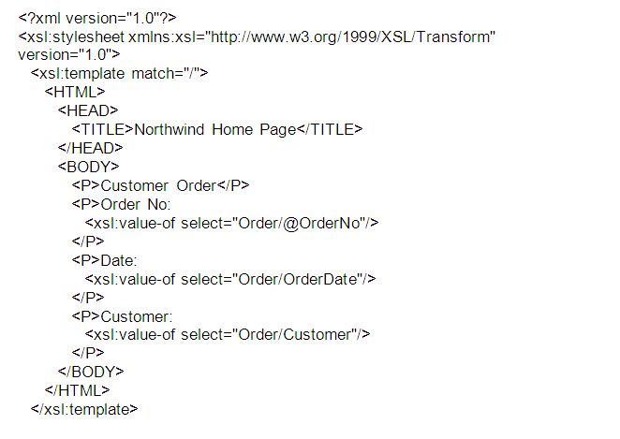

Bài tập 2

a) Soạn thảo tập tin XML tên ListStudent.xml

<?xml version="1.0"?>
<?xml:stylesheet type="text/xsl" href="ListStudent.xsl"?>
<Students>
<Student>
<name>Truong Dinh Huy</name>
<age>28</age>
<address>
<email>huytd@yahoo.com</email>
</address>
<physical_attributes>
<leg_measurement inside="1.62"/>
</physical_attributes>
<mark> 8 </mark>
</Student>
<Student>
<name>Nguyen Ngoc Anh</name>
<age>29</age>
<address>
<email>anhnn@yahoo.com</email>
</address>
<physical_attributes>
<leg_measurement inside="1.90"/>
</physical_attributes>
<mark> 10 </mark>
</Student>
<Student>
<name>Nguyen Quoc Nguyen</name>
<age>27</age>
<address>
<email>Nguyennq@dsp.com.vn</email>
</address>
<physical_attributes>
<leg_measurement inside="1.70"/>
</physical_attributes>
<mark> 7 </mark>
</Student>
</Students>

b) Hiển thị nội dung dữ liệu XML trong trình duyệt sử dụng XSL với tên ListStudent.xsl

<?xml version="1.0"?>
<xsl:stylesheet xmlns:xsl="http://www.w3.org/1999/XSL/Transform" version="1.0">
<xsl:template match="/">
<html>
<body>
<h2 align="center"><font color="#FF0000" > Chuyen Doi du lieu dang XML sang HTML </font></h2>
<table border="1" cellspacing="0" width="100%" bordercolor="#009900">
<tr>
<th>Name</th>
<th>Age</th>
<th>E-mail</th>
<th>Inside leg</th>
<th>mark</th>
</tr>
<xsl:for-each select="Students/Student">
<tr>
<td align="left"><font color="#000080">
<xsl:value-of select="name"/>
</font>
</td>
<td align="center"><font color="#000080">
<xsl:value-of select="age"/>
</font>
</td>
<td align="left"><font color="#000080" >
<xsl:value-of select="address/email"/>
</font>
</td>
<td align="center"><font color="#000080">
<xsl:value-of select="physical_attributes/leg_measurement/@inside"/>
</font>
</td>
<td align="center"><font color="#000080">
<xsl:value-of select="mark"/>
</font>
</td>
</tr>
</xsl:for-each>
</table>
</body></html>
</xsl:template>
</xsl:stylesheet>

Bài tập 3

a) Soạn thảo tập tin XML tên disk.xml
<?xml version="1.0" encoding="ISO-8859-1"?>
<?xml-stylesheet type="text/xsl" href="cdcatalog-if.xsl"?>
<catalog>
<cd>
<title>Empire Burlesque</title>
<artist>Bob Dylan</artist>
<country>USA</country>
<company>Columbia</company>
<price>10.90</price>
<year>1985</year>
</cd>
<cd>
<title>Hide your heart</title>
<artist>Bonnie Tyler</artist>
<country>UK</country>
<company>CBS Records</company>
<price>9.90</price>
<year>1988</year>
</cd>
<cd>
<title>Greatest Hits</title>
<artist>Dolly Parton</artist>
<country>USA</country>
<company>RCA</company>
<price>9.90</price>
<year>1982</year>
</cd>
<cd>
<title>Still got the blues</title>
<artist>Gary Moore</artist>
<country>UK</country>
<company>Virgin records</company>
<price>10.20</price>
<year>1990</year>
</cd>
<cd>
<title>Eros</title>
<artist>Eros Ramazzotti</artist>
<country>EU</country>
<company>BMG</company>
<price>9.90</price>
<year>1997</year>
</cd>
<cd>
<title>One night only</title>
<artist>Bee Gees</artist>
<country>UK</country>
<company>Polydor</company>
<price>10.90</price>
<year>1998</year>
</cd>
</catalog>
b) Sử dụng các cấu trúc chỉ dẫn <xsl:template>, <xsl:value-of>, <xsl:for-each>, <xsl:if>…để hiển thị nội dung file disk.xml trên theo kết quả yêu cầu cho dưới đây (với điều kiện price>10)

Title | Artist | Price
Empire Burlesque | Bob Dylan | 10.90
Still got the blues | Gary Moore | 10.20
One night only | Bee Gees | 10.90

<xsl:for-each select="catalog/cd">
<xsl:if test="price &gt; 10">
<tr>
<td><xsl:value-of select="title"/></td>
<td><xsl:value-of select="artist"/></td>
</tr>
</xsl:if>
</xsl:for-each>

